***Questions & Answers***

**Given the provided data, what are three conclusion that we can draw about crowdfunding campaigns?**

Of all of the category, ‘plays’ that’s under the parent category ‘theatre’ is the most popular project across all recorded countries and has the highest number of successful outcomes, but also the most failed project (Fig 1). The parent-category with the least number of successful projects is ‘Games’ which is the only category that has more failed projects than successful projects (Fig 1).

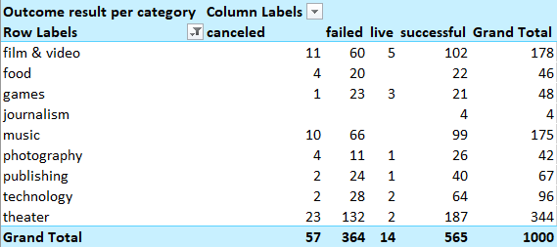

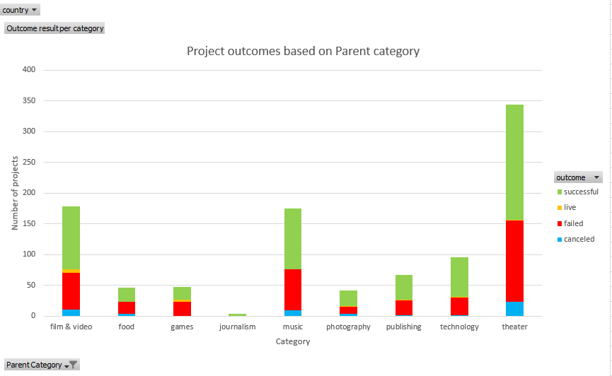

Figure 1: Table chart of the counted projects under certain criteria, with theatre containing the highest amount of project. The bar graph visualises the differences in the amount of project across all categories and the differences in success and failure amount for each category.

Based the month’s success and failed amount across all category, July has the highest number of successful projects between 2010 and 2020. When analysing the graph for category ‘theatre’ due to containing the highest number of projects in record, June and September shown to have better performance with higher differences between the number of successful and failed project being more than 10 (Fig 2).

Figure 2. Line graph showcasing the total number of projects outcome for each month across the years 2010 and 2020.

When comparing the success and failure rate among each country with all of the category, the conclusion would be that among the different recorded countries, GB (United Kingdom) has the best success and failure percentage among the countries with a score of 58% and 38% respectively. The second-best country is USA with a percentage of 57% and 36%, and then third place is AU (Australia) with a score of 56% and 37% respectively.

**What are some limitations of this dataset?**

One such limitation of the dataset would be that it doesn’t completely provide a true success and failure rate. For instance, the success rate for project under the ‘journalism’ category is 100%, however there’s only 4 projects in record. While under the ‘food’ category, the success/fail rate is close to 50% despite having more project crowdfunded. This mainly stems from specific category where small number of projects have 100% success rate. This lack of equal number of projects is also apparent with countries, for instance USA has a record of 763 total projects, whereas IT (Italy) has a total of 48 projects.

Another limitation with the dataset is that some projects had less days for crowdfunding until the deadline while other projects had crowdfunding duration in years. When examining the projects that have failed, there’s a wide range of projects that lasted only a few days, while other projects stayed active for one months. In addition to having varied crowdfund goal, it’s difficult to know determine whether it failed because it doesn’t have enough time to reach the goal or if the crowdfunding goal was too high to reach.

**What are some other possible tables and/or graphs that we could create, and what additional value would they provide?**

If there’s other possible values that can be obtain, it would be a ‘scatter plot’. The plot would be listing all of the successful project’s funded goal based on how long the crowdfunding lasted. With the scatter plot, there may be a certain trend which can give an idea of how long the crowdfund need s in order to achieve a certain crowdfunding goal.

**Bonus & Statistical Analysis**

For the bonus worksheet, the “countifs” command is used to automatically count the number of projects based on specific criteria. Afterward, the percentage is written to automatically determine its percentage. Afterward, the table is displayed as a line graph.

For the statistical analysis, the table is calculated to determine its variability.

**Mean & Median summary**

By comparing the mean and median between the two outcomes, the ‘successful’ campaign has more backers on average than the ‘failed’ campaign. The median also supports this as the value under ‘successful campaigns’ is higher.

**Variance difference between “successful” & “failed”**

The variance value for both campaigns are shown to be extremely high, meaning that the variability is vast and spread out from the mean. However, despite the extreme value, the result is somewhat valid. This is because the number range is extremely large, the difference is 7279 for ‘successful campaign’ and 6080 for ‘failed campaign’ when comparing the lowest and highest value. Another reason would be due to the result rarely showing any projects with identical number of backers, increasing the variability.

When analysing the variance and standard deviation between the two campaign, the ‘successful’ campaign has more dispersed number of backers among the projects.